



Faculty of Technology, Department of Computer Engineering

## B. Tech. CE Semester – V

Subject: (CE – 515) Advanced Technologies Project Title:

**Blogging Website**

By**:**

Maliha Nan - CE074(17CEUOS109)



Prof. Prashant M.Jadav

Prof. Parth R. Dave





Faculty of Technology, Department of Computer Engineering



This is to certify that Advanced Technologies Project entitled “**Blogging Website**” is the bona fide report of work carried out by

1. **Maliha Nan (17CEUOS109)**

Of Department of Computer Engineering, Semester V, academic year 2019-2020, under our supervision and guidance.



|  |  |  |
| --- | --- | --- |
| **Prof. Prashant M. Jadav**  Assistant Professor of Department of Computer Engineering, Dharmsinh  Desai University, Nadiad | **Prof. Parth R. Dave**  Assistant Professor of Department of Computer Engineering, Dharmsinh  Desai University, Nadiad | **Dr. C. K. Bhensdadia**  Head of Department of Computer Engineering, Dharmsinh Desai  University, Nadiad |

*Table of Contents*

1. Abstract 4
2. Introduction 5
   1. Project Details:BriefIntroduction

2.2Technology andToolsUsed

1. SoftwareRequirementSpecifications 6

3.1 Types of Users... 6

* 1. SystemFunctionalRequirements 6
  2. OtherNon‐FunctionalRequirements 09

1. Design 10
   1. XML…………………… 10
   2. DTD……………………. 12
   3. XSD……………………. 13
   4. XSLT…………………… 15
   5. E-RDiagram………. 16

4.6dataDictionary………………………………………………………………..17

1. ImplementationDetails 19
   1. Modules…………….. 19
2. Testing 21
   1. TestingMethod……………………………………………………………..21

6.4TestCases 21

1. Screen‐shots oftheSystem 23
2. Conclusion 26
3. LimitationsofSystem 27
4. Future Extensions totheSystem 27
5. Bibliography 28



Blogging helps business owners to engage with customers. It connects similar

thinkers and communities of people worldwide. Blogging helps to get more

website traffic from search engines. It helps journalists to share personal views on

the cause with their fans. It could also help teachers to connect with their students.

In a world where everyone has an opinion to share, providing a platform is only

necessary. This project lets the user thus create their own blogs, regularly. It

provides a simple solution for writers to manage their blogs. It provides a platform

for the users to read blogs that other users would post and also share their opinion

on them by liking or commenting on them. Thus it provides a place for users to

share their opinion.

**1.1 Purpose**

The purpose of the document is to collect and analyze all assorted ideas that have come up to define the system, its requirement with respect to end users. Also, we shall predict and sort out how we hope this system will be used in order to gain a better understanding of the project, outline concepts that may be developed later, and document ideas that are being considered, but may be discarded as the system develops.

In short, the purpose of this SRS document is to provide a detailed overview of our software product, its parameters and goals. This document describes the project’s target audience, its user interface and software requirements. It defines how our clients, team and end user see the system and its functionality.

**1.2 Scope**

Primarily, the scope pertains to any user wanting to write/read blogs. It focuses on allowing people to express themselves in a simple way.

It does not identify any specific method, nomenclature or tool for preparing an SRS.

**1.3 Overview**

The remaining sections of this document provide a general description, including characteristics of the users of this project, the functional and data requirements of the system.



# Brief Introduction

BlogSite is a web application. This application allows you to write blogs. It also allows you to edit or delete them anytime. It allows you to see the likes and comments on your post on your dashboard. You can also view, like and comment on other user’s blogs.

* 1. **Tools/TechnologiesUsed**



Tool : Visual Studio Code



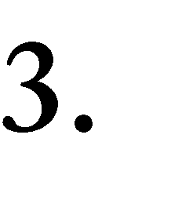

* 1. **Types of Users:-**

1. End User
   1. **System FunctionalRequirements**

**R.1:End-User:**

**-**R.1.1: Login

Description: user must login to system to manage their blogs by entering email

and password.

Input: Email and Password

Output: If user credentials are validated then user can login into the system,

otherwise error message is shown.

-R.1.2: Register

Description: user can register to system by adding some details like

name, email-id, password, contact number and website name.

Input: User Details.

Output: If all the necessary registration details are validated against

Their corresponding criteria then an account is created. Otherwise, error

message is shown.

-R.1.4: Manage Own Blogs

-R.1.4.1: Add Blog

Description: User can add a blog by providing title, content and tags.

Input: Blog details

Output: Blog Shown

-R.1.4.1: Edit Blog

Description: User can edit a blog by providing title, content and tags.

Input: Blog details

Output: Blog Shown

-R.1.4.1: Delete Blog

Description: User can delete a blog.

Input: User selection

Output: Updated blog-list Shown

-R.1.4.1: View Blogs

Description: User can view his/her own blogs and the likes, comments on it.

Input: User selection

Output: Blogs Shown

-R.1.5: Action on other’s blogs

-R.1.5.1: View Blogs

Description: User can view blogs of all users.

Input: User selection

Output: Blogs Shown

-R.1.4.1: Like Blog

Description: User can like a blog.

Input: User selection

Output: Blog Liked

-R.1.4.1: Comment on a Blog

Description: User can comment on a blog.

Input: Comment

Output: Comment Added

-R.1.4.1: Search a User’s website

Description: User can view a website.

Input: website name

Output: website shown

-R.1.6: Send Message to admin

Description: User can send his/her feedback.

Input: Message

Output: message added

* 1. **Other NonfunctionalRequirements**

1. **Performance**



1. **Safety**



.

1. **Reliability**



1. **Database**





# XML

<?xml version="1.0" encoding="UTF-8" ?>

<?xml-stylesheet type="text/xsl" href="website.xslt"?>

<?xml-stylesheet type="text/css" href="website.css"?>

<websites>

<website user_id="001">

<name>Drew Binsky</name>

<pages>

<page id="1">

<theme id="2"/>

<title>2018 Recap</title>

<cover>images/bali.jpg</cover>

<content>

<paras>

<para id="1">

<title>1. Isfahan, Iran</title>

<image>images/isfahan.jpeg</image>

<writeup>

I cannot tell you how much I love Iran after spending 2 weeks there. It’s easily most misconceived country in the world and one of my absolute favorites. The most enjoyable city for me was Isfahan, home to the world’s second biggest city square and amazing architecture! Iranians are some of the most hospitable, friendly and kind people that you will ever meet and I’m already looking forward to my next trip there!

</writeup>

</para>

<para id="2">

<title>2. Omo Valley</title>

<image>images/omo.jpg</image>

<writeup>

In Ethiopia, I went to the Omo valley in the south western part of the country to visit the most remote tribes in Africa (and maybe in the world). Tens of thousands of people are living just like humans lived tens of thousands of years ago, and it was surreal to witness. The nomadic Mursi tribe was most fascinating with their giant pierced lip plates and, over-the-top feathered headwear. It was a special experience to walk through their local markets, witness their traditional dances and see how they eat and interact. I hope to be back there again soon.

</writeup>

</para>

<para id="3">

<title>3. Somaliland</title>

<image>images/somaliland.jpg</image>

<writeup>

Another underrated country is Somalia, which I visited the sovereign north state of Somaliland for 5 days at the beginning of 2018. Going in, I was very nervous as the media says nothing good about Somalia, but I had a very safe and exciting trip! The capital of Hargeisa was filled with life, markets, and delicious food. The best part overall was the camel market and visiting a UNESCO site called Las Geel which is old rock carvings. A remarkable place, indeed.

</writeup>

</para>

</paras>

<side>

<paras>

<para id="4">

<image>images/me.png</image>

<writeup>Hello! I'm Drew Brinsky.I've been to 166 countries while making daily videos.</writeup>

</para>

</paras>

</side>

</content>

</page>

<page id="2">

<theme id="4"/>

<title>About Drew</title>

<cover>images/drew.jpg</cover>

<content>

<paras>

<para id="1">

<title>Hello! My name is Drew Binsky</title>

<writeup>

I’ve been to 169 countries since 2012, and I work as a full-time video maker (@DrewBinsky® videos), travel blogger and content creator with 3.7M+ social media followers and 920M+ video views. I am also a 5-handicap golfer and a 2X Guinness World Record holder. I grew up in sunny Scottsdale, Arizona and graduated from The University of Wisconsin-Madison, with a double-major in economics and entrepreneurship. I am obsessed with my college, and I wouldn’t be where I am today if I went to any other school. Go Badgers!

</writeup>

</para>

<para id="2">

<image>images/tokyo.jpg</image>

<writeup>

The travel bug first hit me when I studied abroad in Prague during my Junior year of college (Jan – May 2012). After having an incredible semester of living in Europe and traveling to 20+ countries, I knew I wanted to make a career out of traveling.

Two months after graduating college, I moved to South Korea to become an English teacher. When I was accepted for the job, I knew nothing about teaching (90% of my college classes were business related), but I saw teaching overseas as a great opportunity to live and work abroad. And it surely was! I neglected getting a corporate job and following “The American Dream,” because it just wasn’t for me.

</writeup>

</para>

</paras>

<side>

<paras>

<para id="4">

<image>images/me.jpg</image>

<writeup>Hello! I'm Drew Brinsky.I've been to 166 countries while making daily videos.</writeup>

</para>

</paras>

</side>

</content>

</page>

<page id="3">

<theme id="1"/>

<title>Highlights From a 6 Day Road Trip in FLORIDA</title>

<content>

<paras>

<para id="1">

<image>images/.jpg</image>

<writeup>

I just wrapped up an incredible, action-packed road trip to Florida over the last 6 days in collaboration with Visit Florida. It was my first time back in the sunshine state since 2007, so it was great to be here with fresh eyes and new perspectives. My girlfriend and I flew into Fort Myers, and then visited Cape Coral, Babcock Ranch, Punta Gorda, Englewood, the Everglades, Marco Island, Naples and finally headed East to Fort Lauderdale and Miami. We drove more than 400 miles in total and just had the time of our lives.

</writeup>

</para>

<para id="2">

<title>Part 1 – Fort Myers, Charlotte Harbor and Punta Gorda</title>

<image>images/fort_myers.jpg</image>

<writeup>

I personally think that Florida’s South West part is the best kept secret in the state. It’s less commercial, less touristy but has the same stunning beaches, ridiculous views and relaxing lifestyle as East or North in the state.

For me, the two highlights of Charlotte County were visiting Babcock Ranch and the beaches in Englewood. Babcock ranch is a 27 square mile planned community, that is America’s first solar powered town. They are 100% powered by solar energy, as almost 500,000 solar panels can be found in nearby fields and on the top of commercial buildings. Being solar powered means electric driverless cars to get around, top-of-the-line technology with free wifi outside (everywhere!) and work out machines that pump energy back into the ground. I was thrilled to be here and witness such forward thinking and innovation – and I hope that the rest of the U.S. will soon follow their footsteps.

</writeup>

</para>

<para id="3">

<title>Part 2 – Naples and Surrounding Areas</title>

<image>images/naple.jpg</image>

<writeup>

As we headed South down the West coast, our first stop was Everglades City to jump on board a air boat (powered by a huge fan on back). The boat took us around the Everglades – AKA the swamp where the alligators live! Even though it was the low season for gators (because of the low water level and high concentration of salt) – we did manage to see a few and I cannot believe how big they are.

After the Everglades, we headed to the quaint town of Naples, which I honestly knew nothing about before arriving. And I quickly figured out that it’s one of America’s richest cities, with the second highest density of millionaires per capita and households that are upwards of $10 million dollars. While the people were mostly over 65 and retired, there was definitely a fair share of younger, hip areas (check out Bar Tulia!) and the beaches did not disappoint.

</writeup>

</para>

</paras>

</content>

</page>

</pages>

</website>

</websites>

**4.2 DTD**

<!ELEMENT Websites(Website+)>

<!ELEMENT Website(Name,Pages(Page+))>

<!ELEMENT Name (#PCDATA)>

<!ELEMENT Page(theme, title, cover, content)>

<!ELEMENT theme (#PCDATA)>

<!ELEMENT title (#PCDATA)>

<!ELEMENT cover (#PCDATA)>

<!ELEMENT content (paras(para+)>

<!ELEMENT para (title, writeup)>

<!ELEMENT title (#PCDATA)>

<!ELEMENT writeup (#PCDATA)>

* 1. **XSD**

<?xml version="1.0" encoding="UTF-8" ?>

<xs:schema xmlns:xs="http://www.w3.org/2001/XMLSchema"

elementFormDefault="qualified"

attributeFormDefault="unqualified">

<xs:element name="websites">

<xs:complexType>

<xs:sequence>

<xs:element name="website" type="websiteType" minOccurs="0" maxOccurs="unbounded"/>

</xs:sequence>

</xs:complexType>

</xs:element>

<xs:complexType name="websiteType">

<xs:sequence>

<xs:element name="name" type="nameSimpleType"/>

<xs:element name="pages" type="pagesType"/>

</xs:sequence>

<xs:attribute name="user_id" type="xs:int" use="required" />

</xs:complexType>

<xs:simpleType name="nameSimpleType">

<xs:restriction base="xs:string">

<xs:maxLength value="50"/>

</xs:restriction>

</xs:simpleType>

<xs:complexType name="pagesType">

<xs:sequence>

<xs:element name="page" type="pageType" minOccurs="0" maxOccurs="unbounded"/>

</xs:sequence>

</xs:complexType>

<xs:complexType name="pageType">

<xs:sequence>

<xs:element name="theme" type="themeType"/>

<xs:element name="title" type="xs:string"/>

<xs:element name="cover" type="xs:string" use="implied"/>

<xs:element name="content" type="contentType" use="implied"/>

</xs:sequence>

<xs:attribute name="id" type="xs:int" use="required" />

</xs:complexType>

<xs:complexType name="themeType">

<xs:attribute name="id" type="xs:int" use="required" />

</xs:complexType>

<xs:complexType name="contentType">

<xs:sequence>

<xs:element name="paras" type="parasType"/>

<xs:element name="side" type="parasType" use="implied"/>

</xs:sequence>

</xs:complexType>

<xs:complexType name="parasType">

<xs:sequence>

<xs:element name="para" type="paraType" minOccurs="0" maxOccurs="unbounded"/>

</xs:sequence>

</xs:complexType>

<xs:complexType name="paraType">

<xs:sequence>

<xs:element name="title" type="xs:string" use="impled"/>

<xs:element name="image" type="xs:string" use="impled"/>

<xs:element name="writeup" type="xs:string" use="impled"/>

</xs:sequence>

<xs:attribute name="id" type="xs:int" use="required" />

</xs:complexType>

</xs:schema>

* 1. **XSLT**

<?xml version="1.0" encoding="UTF-8" ?>

<xsl:stylesheet version="1.0"

xmlns:xsl="http://www.w3.org/1999/XSL/Transform">

<xsl:template match="/websites/website[@user_id='001']">

<html>

<head>

<title><xsl:value-of select="name"/></title>

</head>

<body>

<table width="100%">

<xsl:apply-templates select="pages/page[@id='1']"/>

</table>

</body>

</html>

</xsl:template>

<xsl:template match="pages/page[@id='1']">

<tr>

<td colspan="2">

<h1><xsl:value-of select="title"/></h1>

</td>

</tr>

<tr>

<td style="width:75%;"><img src="{cover}" width="100%"/></td>

<td style="width:25%;"><xsl:apply-templates select="content/side/paras"/></td>

</tr>

<tr>

<td><xsl:apply-templates select="content/paras"/></td>

</tr>

</xsl:template>

<xsl:template match="content/side/paras">

<xsl:for-each select="para">

<div style="margin-left:5%;">

<h3><xsl:value-of select="title"/></h3>

<img src="{image}" width="100%"/>

<p><xsl:value-of select="writeup"/></p>

</div>

</xsl:for-each>

</xsl:template>

<xsl:template match="content/paras">

<xsl:for-each select="para">

<h3><xsl:value-of select="title"/></h3>

<img src="{image}" width="50%"/>

<p style="width:7 5%;" ><xsl:value-of select="writeup"/></p>

</xsl:for-each>

</xsl:template>

</xsl:stylesheet>

**4.5 E-R Diagram**

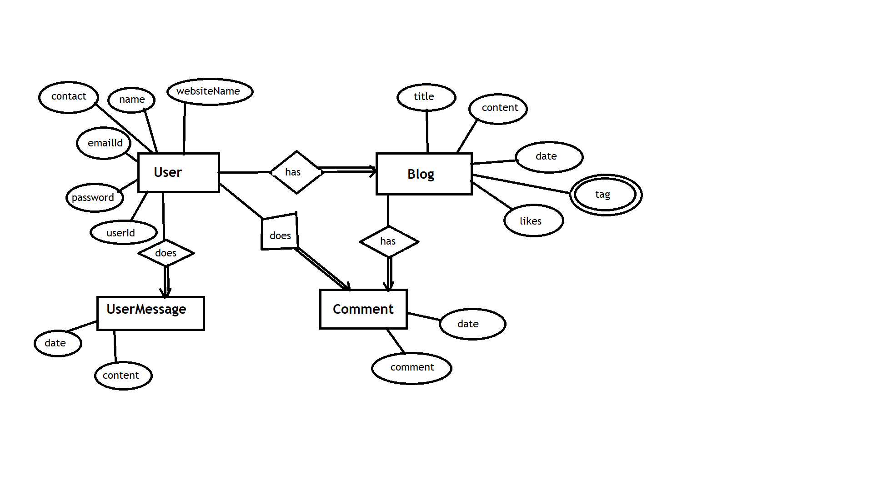

* 1. **Data Dictionary**

|  |  |  |  |  |  |  |  |  |
| --- | --- | --- | --- | --- | --- | --- | --- | --- |
| User | | | | | | | | |
| Sr.  No. | Field  Name | Data  Type | Width | Required | Unique | PK/FK | Referenced  Table | Description |
| 1 | Id | Number | 10 | Yes | Yes | PK |  |  |
| 2 | Name | Varchar2 | 20 | Yes | No |  |  |  |
| 3 | Password | Password | 12 | Yes | No |  |  |  |
| 4 | Email | Email | 20 | Yes | Yes |  |  |  |
| 5 | ContactNo | Varchar2 | 10 | No | No |  |  |  |
| 6 | WebsiteName | Varchar2 | 20 | Yes | Yes |  |  |  |

|  |  |  |  |  |  |  |  |  |
| --- | --- | --- | --- | --- | --- | --- | --- | --- |
| Blog | | | | | | | | |
| Sr.  No. | Field  Name | Data  Type | Width | Required | Unique | PK/FK | Referenced  Table | Description |
| 1 | Id | Number | 7 | Yes | Yes | PK |  |  |
| 2 | Title | Varchar2 | 15 | Yes | No |  |  |  |
| 3 | Content | Varchar2 | 65535 | Yes | No |  |  |  |
| 4 | Date | Date |  | Yes | No |  |  |  |
| 5 | UserId | Number | 10 | Yes | No | FK | User |  |
| 6 | Likes | Number | 4 | Yes | No |  |  |  |
| 7 | Tag | Varchar2 | 65535 | No | No |  |  |  |

|  |  |  |  |  |  |  |  |  |
| --- | --- | --- | --- | --- | --- | --- | --- | --- |
| Comment | | | | | | | | |
| Sr.  No. | Field  Name | Data  Type | Width | Required | Unique | PK/FK | Referenced  Table | Description |
| 1 | Id | Number | 10 | Yes | Yes | PK |  |  |
| 2 | UserId | Number | 10 | Yes | No | FK | User |  |
| 3 | BlogId | Number | 10 | Yes | No | FK | Blog |  |
| 4 | Content | Varchar2 | 65535 | Yes | No |  |  |  |
| 5 | Date | Date |  | Yes | No |  |  |  |

|  |  |  |  |  |  |  |  |  |
| --- | --- | --- | --- | --- | --- | --- | --- | --- |
| UserMessage | | | | | | | | |
| Sr.  No. | Field  Name | Data  Type | Width | Required | Unique | PK/FK | Referenced  Table | Description |
| 1 | Id | Number | 10 | Yes | Yes | PK |  |  |
| 2 | UserId | Varchar2 | 15 | Yes | Yes |  |  |  |
| 3. | Content | Varchar2 | 20 | Yes | No |  |  |  |
| 4 | Date | Number | 3 | Yes | No |  |  |  |



The project is divided into two parts: frontend and the server side.

Frontend is implemented using Angular 7. It has all the services and implements session management.

The server side is implemented using NodeJS, ExpressJS and mongoose.

MongoDb is used for data storage.

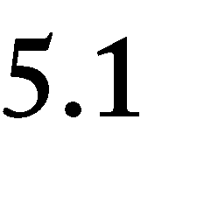**Modules Description**

**AppModule:**

This is the main and the only module implemented. It has references to

app-routing module which implements the routes. It also references all the components and services used. This is the entry module of the system.

**Components:**

1. **LoginComponent:** Thiscomponent does user authentication. It utilizes

**auth.service** for this purpose. It also sets a cookie on successful

registration using ngx-cookie-service.

1. **LogoutComponent:** This component logs out a logged in user. It will

delete the cookie previously set.

1. **RegisterComponent:** This component is used for registration of new

users. It will check for validations on the frontend and then allow for registration. It also uses **auth.service** for making back-end calls

1. **HomeComponent:** This represents the home page of the website and

allows to route to any other component. It uses **NavBarComponent, ContactComponent** and **BlogComponent** forreusableviews. It makes

use of following services: **user.service**, **auth.service**, **blog.service**

* 1. **NavBarComponent:** It has reusable view for navbar and lets

user search using website name.

* 1. **ContactComponent:** It allows users to send message to the admin
  2. **BlogComponent:** It allows create, render, update, delete

functionalities for blogs.

1. **DashboardComponent:** This component lets blogs of a single user to

be seen. It utilizes ShowBlogsComponent to show the blogs.

* 1. **ShowBlogsComponent:** This will show all the blogs of a given

user or blogs by all the users. It allows a blog to be liked and commented. User can also view comments using this component.

1. **ShowAllComponent:** This component is used to see all the blogs by

users in the order of most recent ones. It uses ShowBlogsComponent for displaying, liking and commenting functionality.

  



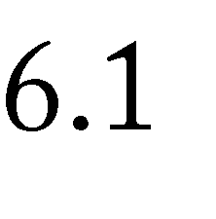

Blackbox Testing has been performed.



Password must be of minimum length=6, maximum length = 10,

password should be strong and password and confirm password must match, required fields cannot be empty. Email-Id and contact number should be valid, email-Id and website name should be unique.

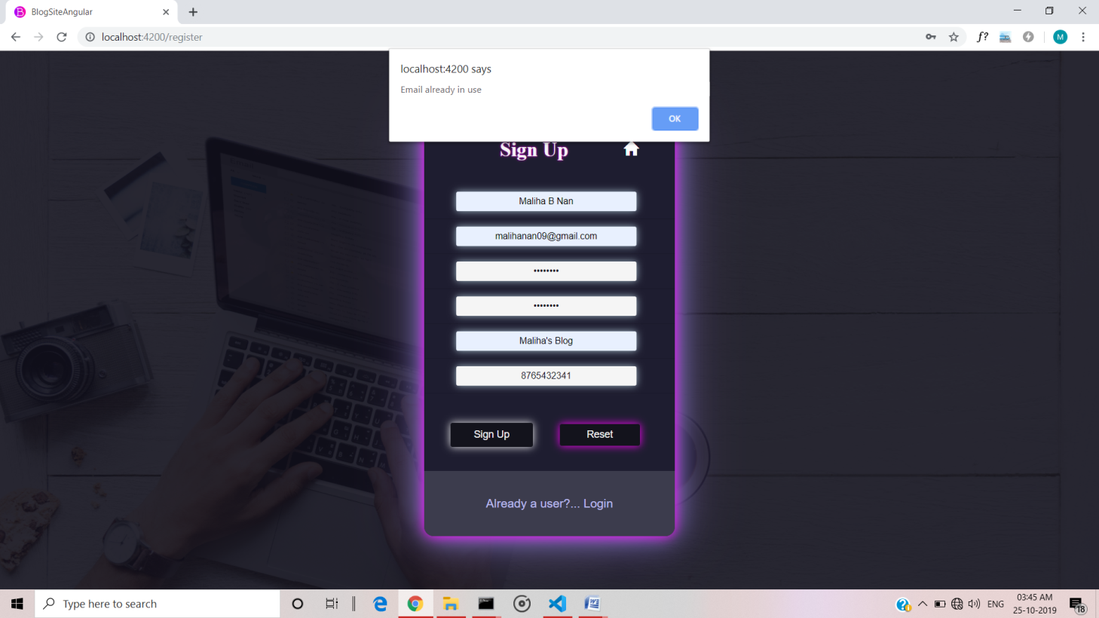



If user tries to do any action that requires authentication, he/she is redirected to the login page.

For eg. When user tries to like a blog, he/she is redirected to login page.



Error is shown on invalid credentials.

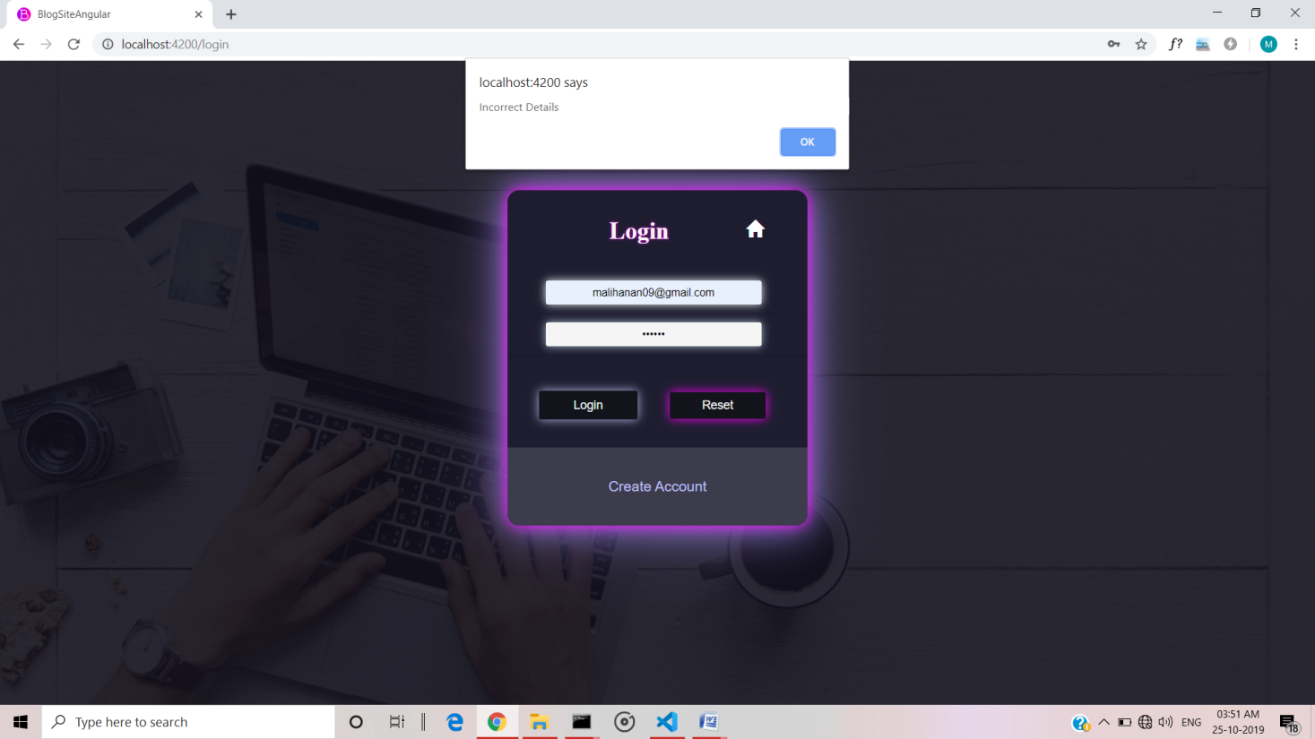





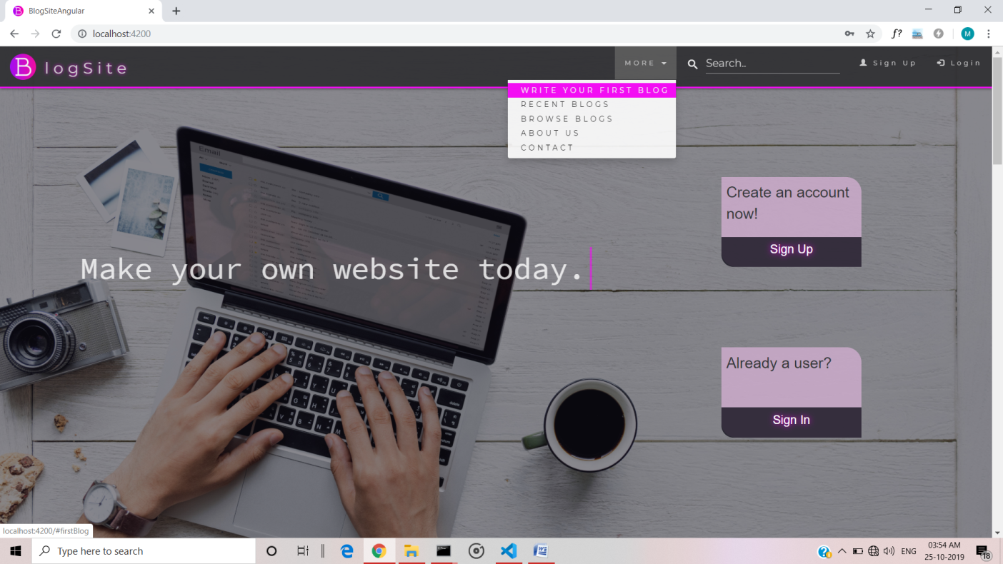Figure7.1: Home Page

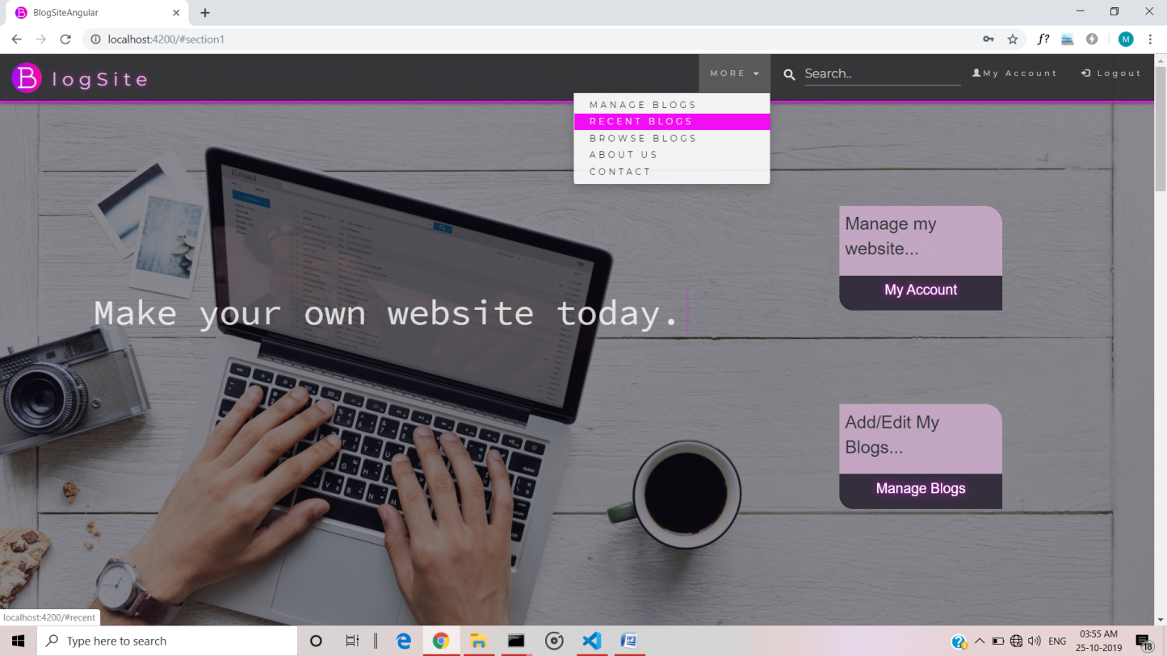

Figure7.2: Home Page for logged in user

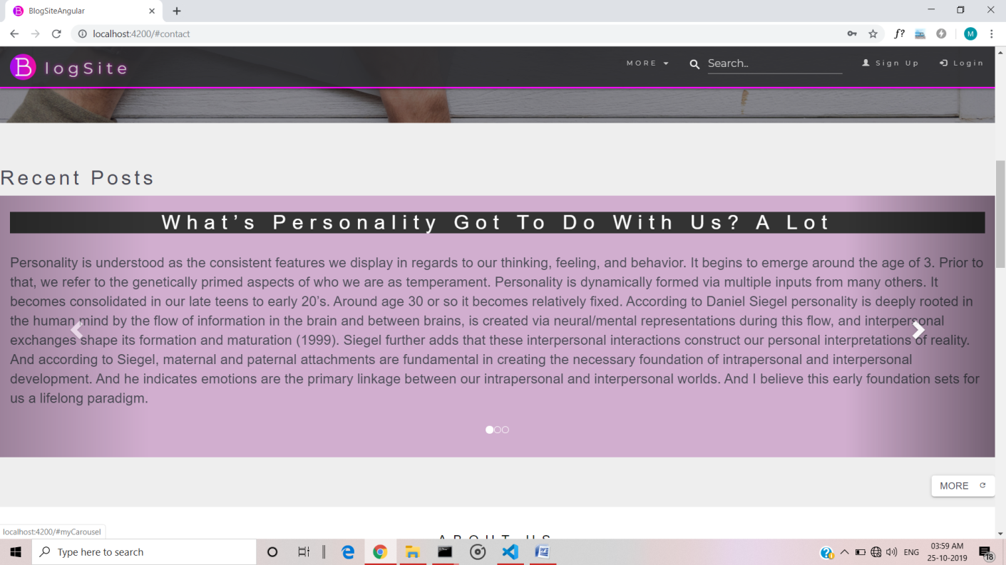

Figure7.3: Home Page: a carousel for most recent blogs

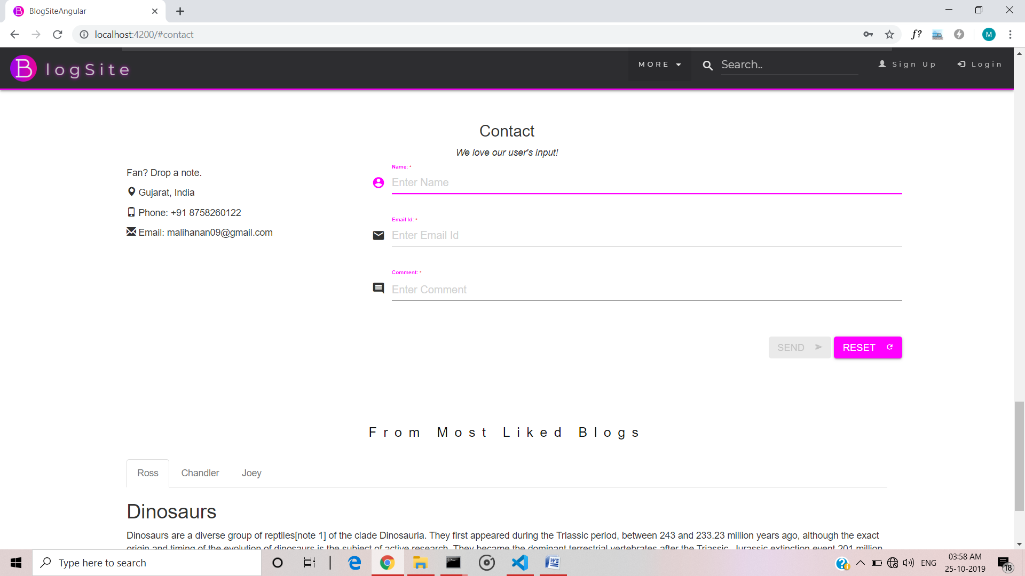

Figure7.4: contact us for sending user messages

(Submit stays disabled until form is valid)

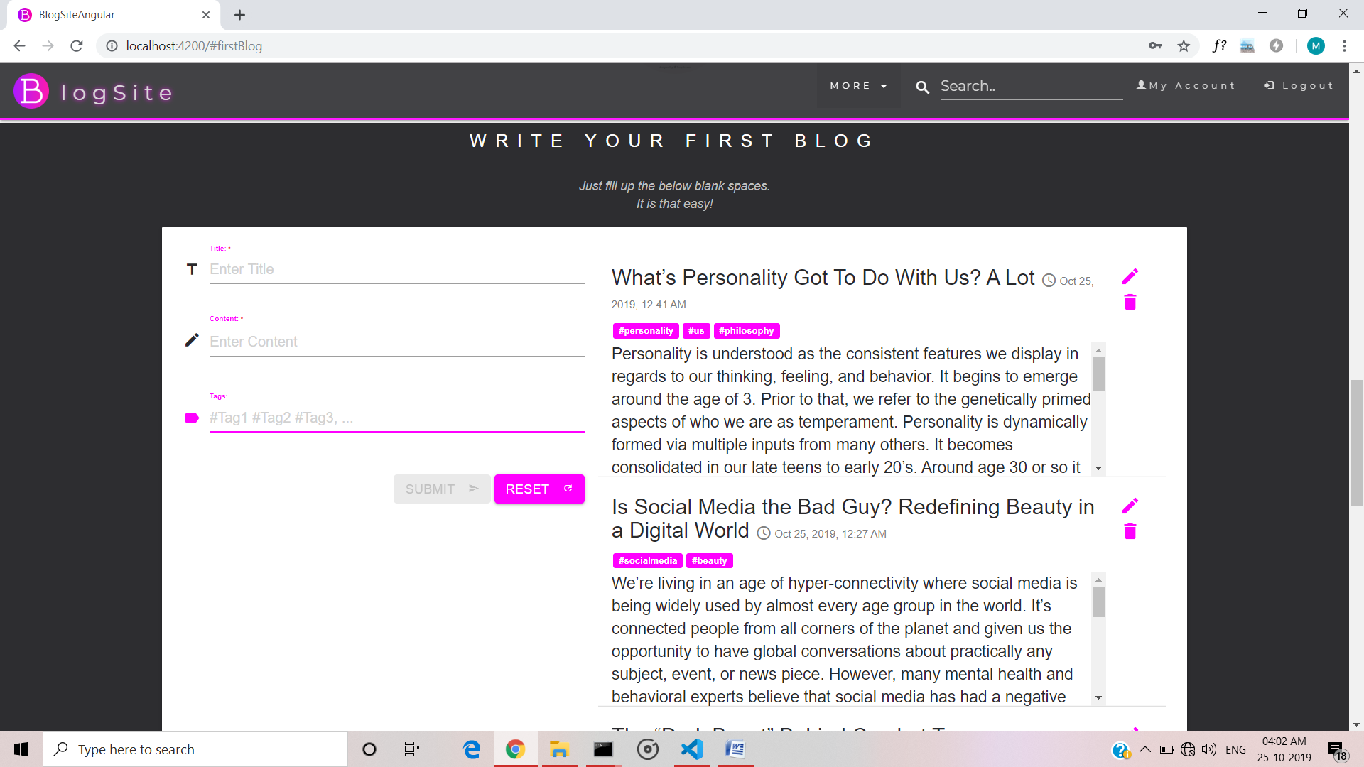

Figure7.4: A manage blog section for CRUD on blogs.

(Submit only allowed if user is logged in)

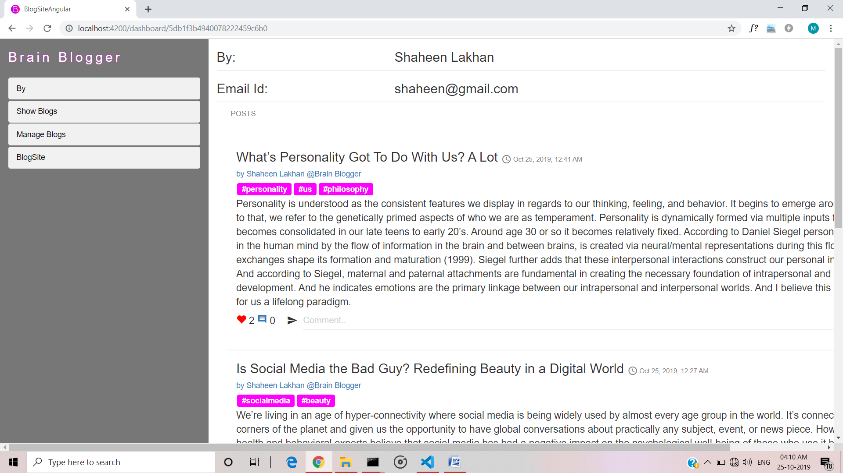

Figure7.5: Dashboard of a user.

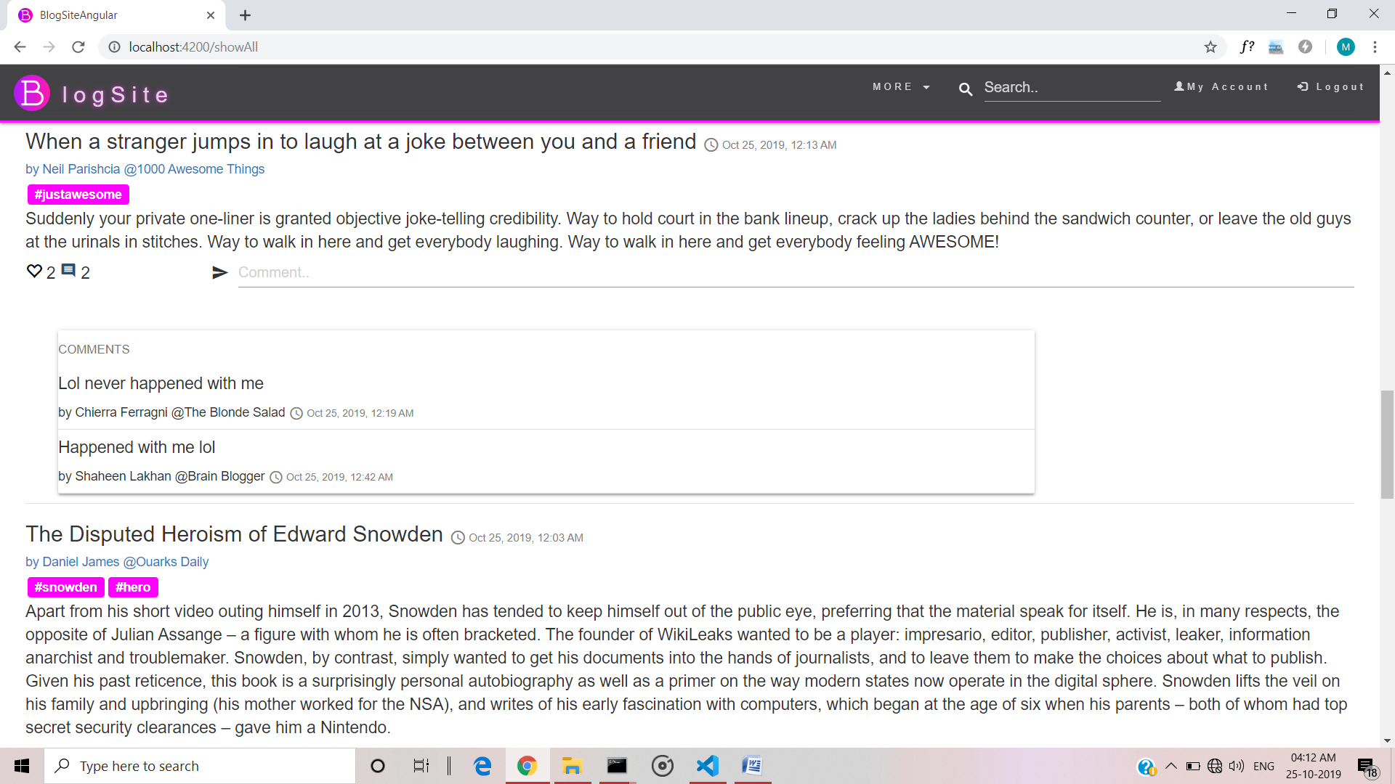

Figure7.5: showing all blogs with likes and can view comments.

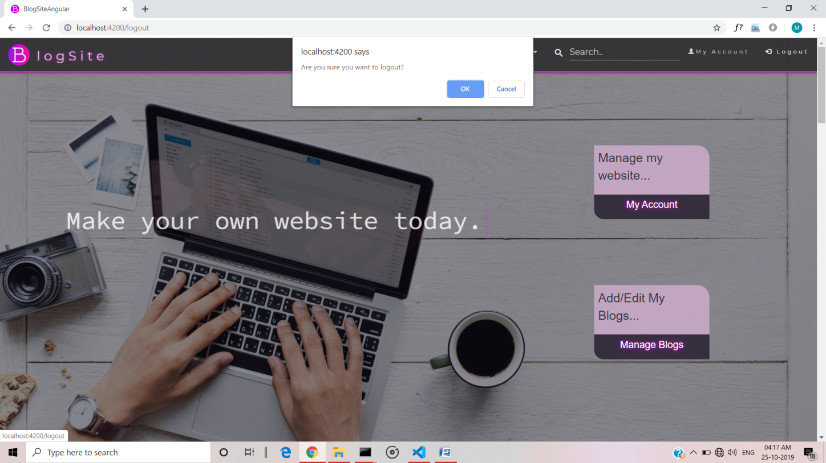

Figure7.6: confirmation for logging out



* User Registration containing all the necessary validations on fields.
* Login
* User Authentication
* Session Management
* Logout
* Add a Blog
* Update Blog
* Delete Blog
* View dashboards of user
* Like Blogs
* Comment on Blogs
* Send message to admin





* + 1. **Limitations**
* Users cannot follow
  + 1. **Functionalities not Implemented**
* Admin site is not implemented
* User cannot follow a website
  + 1. **FutureExtension**
* Following functionality.
* Smart filtering based on likes and follows.
* Extension on ways to write a blog.



➢



1. [https://www.w3schools.com](https://www.w3schools.com/)–For Html,CSS,Bootstrap,XML, JavaScript.
2. https://[www.tutorialspoint.com](http://www.tutorialspoint.com/)‐ForNodeJS, Typescript, Angular.
3. [https://angular.io](https://angular.io/)–For UnderstandingAngular.
4. [https://stackoverflow.com](https://stackoverflow.com/)–For solvingproblems.

➢



1. https://nodejs.org/en/ ‐For download and setup ofNodeJS.
2. https://fonts.google.com –For getting fontsfamilies.
3. [https://www.youtube.com/watch?v=1tRLveSyNz8&t=4413s](https://www.youtube.com/watch?v=1tRLveSyNz8&amp;t=4413s)– Forunderstanding.
4. [https://www.youtube.com/watch?v=MPuXl1DS1vU&t=235s](https://www.youtube.com/watch?v=MPuXl1DS1vU&amp;t=235s)
5. https://www.awfis.com